AFRICAN UNION | 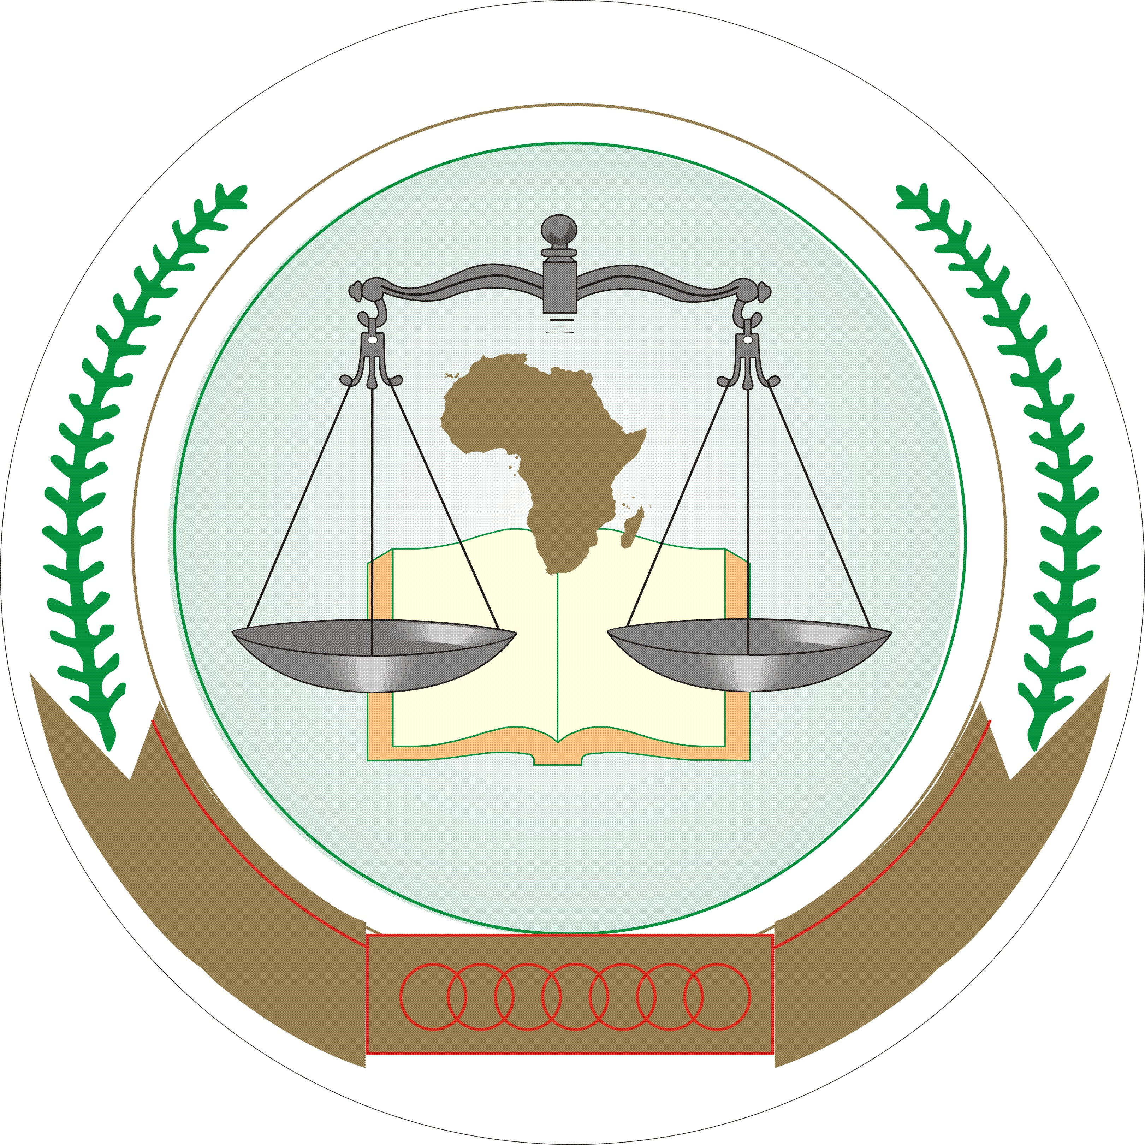 | UNION AFRICAINE
 |  | UNIÃO AFRICANA
AFRICAN COURT ON HUMAN AND PEOPLES’ RIGHTS
COUR AFRICAINE DES DROITS DE L’HOMME ET DES PEUPLES
P.O Box 6274 Arusha, Tanzania Telephone: +255 732 979506/9; Fax: 255 732 979503
Web site: www.african-court.org Email registrar@african-court.org

BID FORM FOR VEHICLES

Submission Date: _______

Lot No. | ITEM DESCRIPTION | BID AMOUNT (USD)
45 | Mercedes Benz E280
46 | Motor Vehicle Toyota Hiace Minibus 15 Seater

____________________ ____________________
Name of Bidder Signature

____________________
ID number

Phone Number: __________ Email: ___________________

NB: Only duly filled and signed bids will be accepted.
Bids to be deposited in sealed envelopes to the tender box of the African Court.

