AFRICAN UNION |  | UNION AFRICAINE
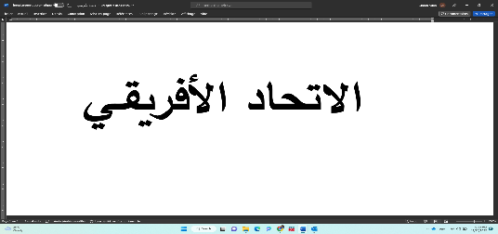 |  | UNIÃO AFRICANA
UNIÓN AFRICANA |  | UMOJA WA AFRIKA
AFRICAN COURT ON HUMAN AND PEOPLES’ RIGHTS
COUR AFRICAINE DES DROITS DE L’HOMME ET DES PEUPLES
P.O. BOX 6274 Arusha, Tanzania Tel: +255 272 510 510
Website: www.african-court.org Email address: registry@african-court.org

REQUEST FOR SETTING ASIDE A JUDGMENT ENTERED IN DEFAULT
Rule 63(2), of the Rules of Court

THE INFORMATION MUST BE TYPED AND NOT HANDWRITTEN

- Respondent State | Click or tap here to enter text.

Represented by :

- Name : | Click or tap here to enter text.
- Gender: |  | Choose an item.
- Position: |  | Click or tap here to enter text.
- Profession : |  | Click or tap here to enter text.
- Postal Address : |  | Click or tap here to enter text.
- Physical Address : |  | Click or tap here to enter text.
- Telephone : |  | Click or tap here to enter text.
- Email : |  | Click or tap here to enter text.

(Attach power of attorney or if the representative is a lawyer, attach a letter of appointment)

- Details of the judgment whose setting aside is sought
    - Parties to the judgment
    - Date of the judgment
    - Operative part of the judgment
    - Date of notification of the judgment

- Grounds for requesting the setting aside of the judgment
Please indicate the point(s) of the judgment which, in your opinion, should be set aside. Please explain the reasons.

Click or tap here to enter text.
Click or tap here to enter text.
Click or tap here to enter text.
Click or tap here to enter text.
Click or tap here to enter text.

- Evidence in support of the Application to set aside the judgment

    - Please list the evidence in support of the Application for judgment review

Click or tap here to enter text.
Click or tap here to enter text.
Click or tap here to enter text.
Click or tap here to enter text.

    - Please attach evidence (original documents or documents certified by the relevant national authorities)

- Summary of the Application
Provide a summary of the Request covering the main points under Number 1 to 4 above. (Not more than three (3) pages, which the Registry will use to publish information about the request on the Court’s website)
Click or tap here to enter text.
Click or tap here to enter text.
Click or tap here to enter text.
Click or tap here to enter text.

- Preferred language of correspondence (tick the applicable one(s))

- Arabic | ☐
- English | ☐
- French | ☐
- Kiswahili | ☐
- Portuguese | ☐
- Spanish | ☐
- Other(s) (Please specify)

Dated at |  | (place),this |  | (day) of |  | (month) |  | (year).

Signed by
RESPONDENT STATE’S REPRESENTATIVE
The completed and signed application form should be scanned and sent in PDF version and in Word version (to facilitate translation) to the following address:

The Registrar
African Court on Human and Peoples’ Rights
Mwalimu Julius Nyerere Conservation Centre
Dodoma Road
P. O. Box 6274,
Arusha, United Republic of Tanzania
Email: registry@african-court.org

Note: There are no filing fees for filing applications (Rule 32(1) of the Rules of Court).
Rule 63(2) of the Rules of Court – Request for annulment of a judgment rendered by default: “The Court may, upon an Application from the defaulting party showing good cause, and within a period not exceeding one year from the date of notification of the judgment, set aside a judgment entered in default in accordance with sub-rule 1 of this Rule”.

